Project/Activity
Solve this crossword puzzle with the help of the given clues.
Across
1. Nagarjuna Sagar is a river valley project. Name the river?
2. The longest river of India.
3. The river which originates from a place known as Beas Kund.
4. The river which rises in the Betul district of MP and flows westwards.
5. The river which was known as the “Sorrow” if West Bengal.
6. The river on which the reservoir for Indira Gandhi canal has been built.
7. The river whose source lies near Rohtang Pass.
8. The longest river of Peninsular India.
Down
9. A tributary of Indus originating from Himachal Pradesh.
10. The river flowing through fault, drains into the Arabian Sea.
11. A river of South India, which receives rain water both in summer and winter.
12. A river which flows through Ladakh, Gilgit and Pakistan.
13. A important river of the Indian desert.
14. The river which joins Chenab in Pakistan.
15. A river which rises at Yamunotri glacier.
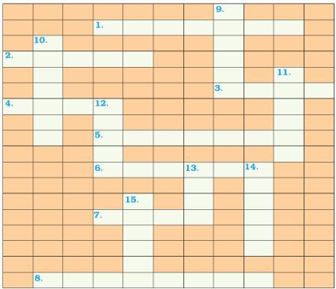

dr

